SIT123: Data Capture Technologies

# Using the Real Time Clock Activity Sheet

## 

## Hardware Required

* Arduino Board
* USB cable
* Adafruit Assembled Data Logging Shield for Arduino (<https://tronixlabs.com.au/arduino/shields/sd-card/adafruit-assembled-data-logging-shield-for-arduino-australia/> )
* CR1220 Coin Cell Battery (<https://tronixlabs.com.au/power/battery/non-rechargeable/cr1220-coin-cell-battery-australia/> )

## Pre-requisites: You must do the following before this task

**Read this sheet from top to bottom**

**Setting Up The SD Card Activity**

## Steps

1. Take the coin cell battery and insert it to the data logger shield as below. Make sure you insert the (+) side of the battery on top.

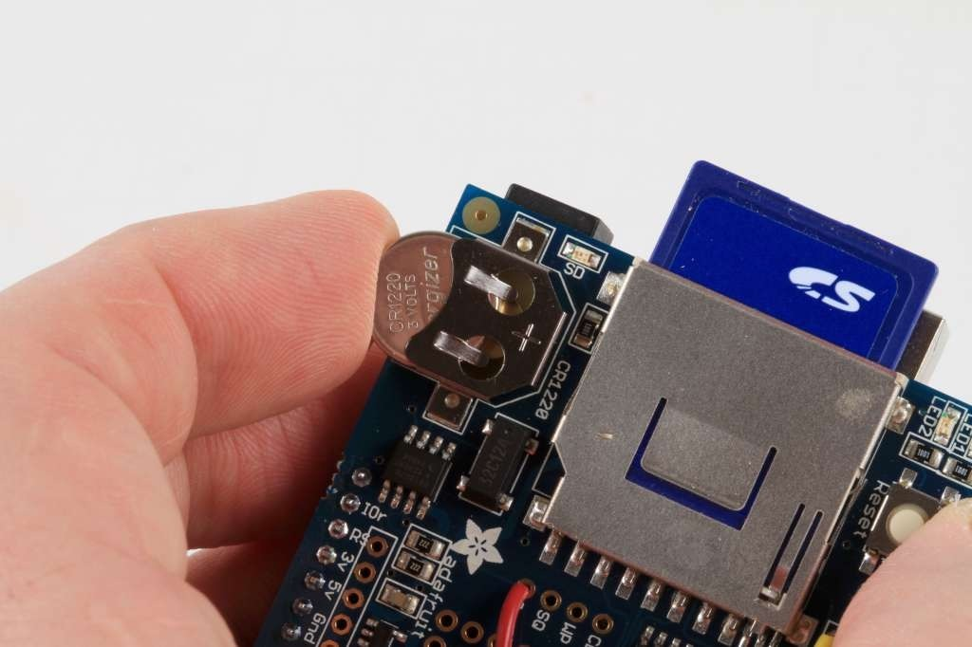

1. The first thing we'll demonstrate is a test sketch that will read the time from the RTC once every 3 seconds.
2. Go to <https://github.com/adafruit/RTClib> and download the library to your computer by clicking ‘Download ZIP’.

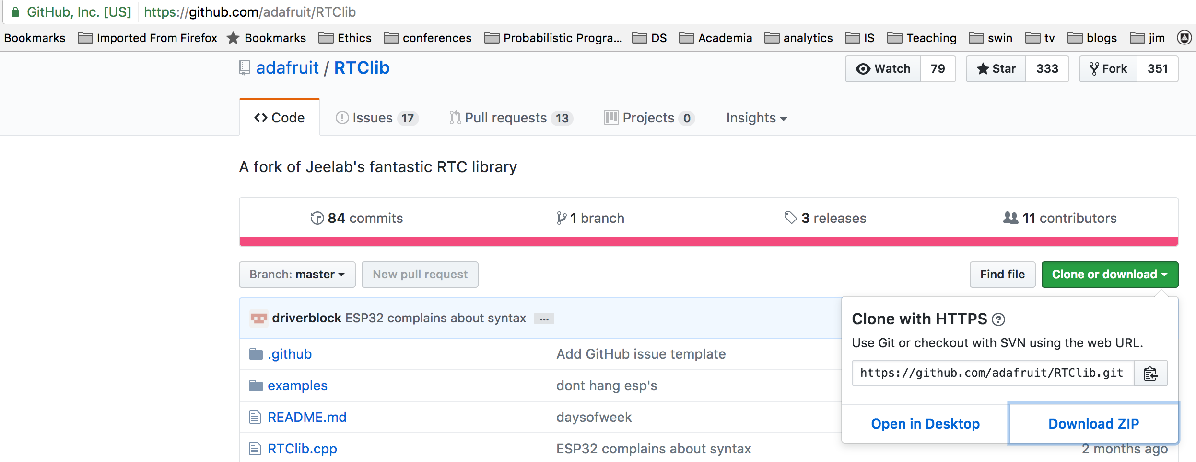

1. Save your Arduino libraries in one location, such as inside Documents/Arduino/Libraries



1. Go to Arduinio IDE & add this downloaded library. To do this, select ‘Sketch’ on the top menu bar -> Select ‘Include Library’ -> Select ‘Add .ZIP library’. A dialog will open asking you to select the zip library. Select the zip file we just downloaded.

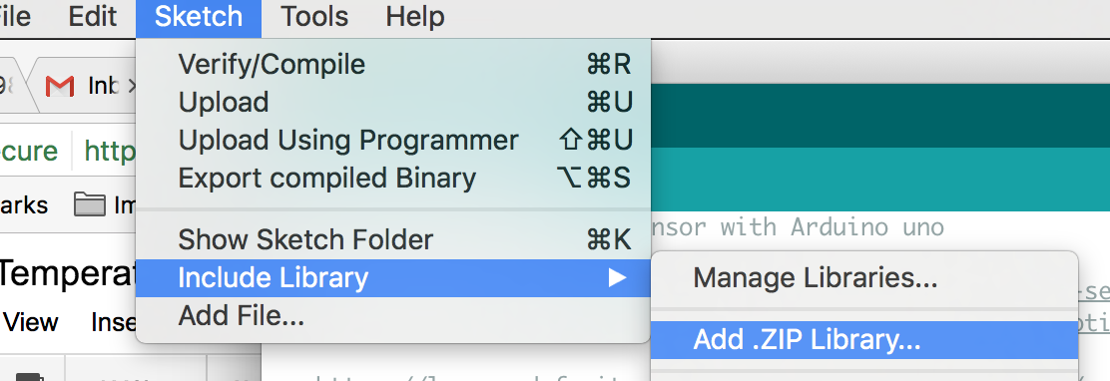

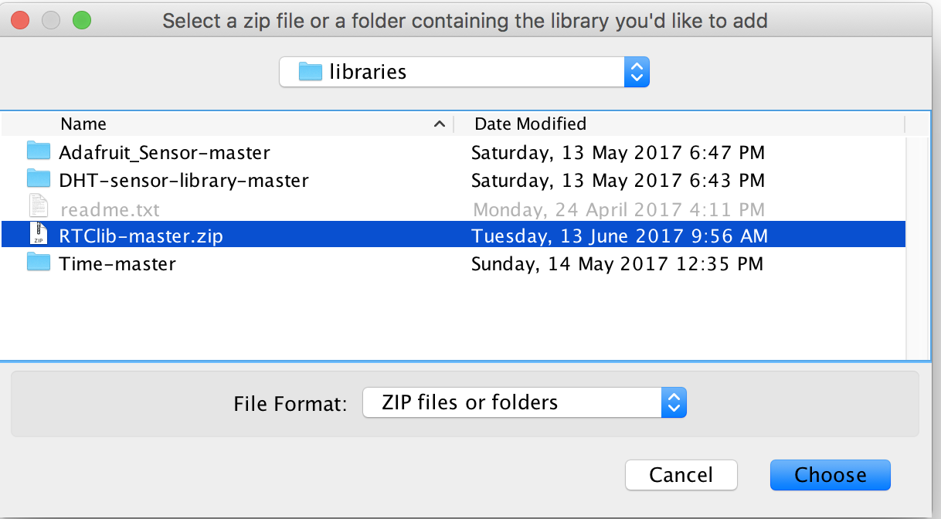

1. In the Arduino IDE, open **File-> Examples->RTClib->pcf8523**

Note: Please check the type of RTC chip used on your data logger. You can find the information next the coin battery on the data logger. If it is “DS1307”, please open **File-> Examples->RTClib->ds1307**

1. **Verify and upload**
2. Now open up the Serial Console and make sure the baud rate is set correctly at 57600 baud you should see the following:

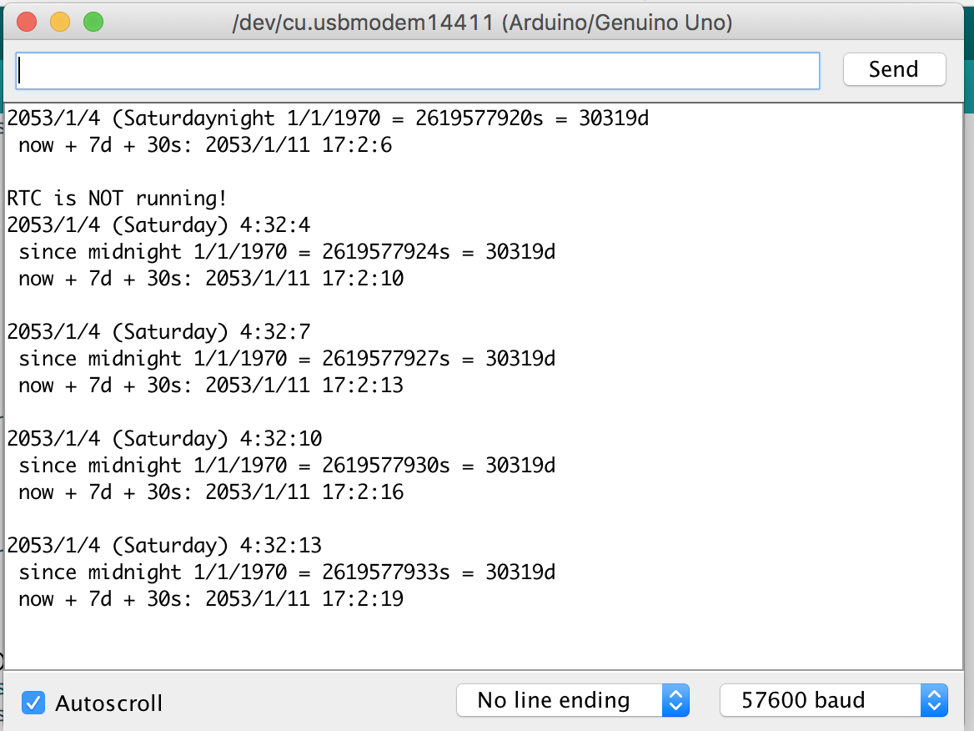

Whenever the RTC chip loses all power (including the backup battery) it will reset to an earlier date and report the time as 0:0:0 or similar. Whenever you set the time, this will kickstart the clock ticking. So, basically, you should never ever remove the battery once you've set the time.

1. You would have noticed that the time printed on the Serial monitor is not the correct date/time. This is what we are going to set in this step. With the same sketch loaded, uncomment the line that starts with **RTC.adjust** like so:

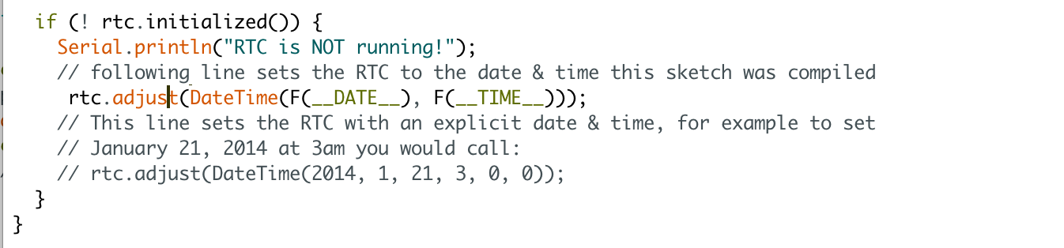

What it does is take the Date and Time according the computer you're using (right when you compile the code) and uses that to program the RTC. You must press the Verify button to compile and then immediately Upload. If you compile and then upload later, the clock will be off by that amount of time.

1. Then open up the Serial monitor window to show that the time has been set.

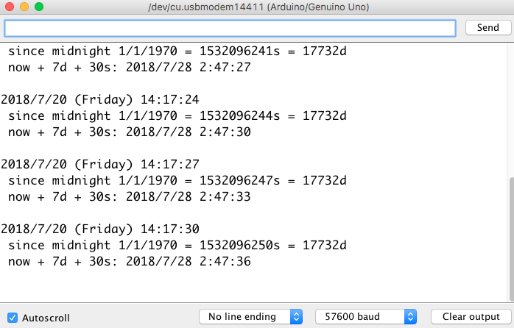

From now on, you won't have to ever set the time again (unless you take the battery out!): the battery will last 5 or more years.

## References

<https://learn.adafruit.com/adafruit-data-logger-shield/using-the-real-time-clock>